Moosters Tickle Me Pink
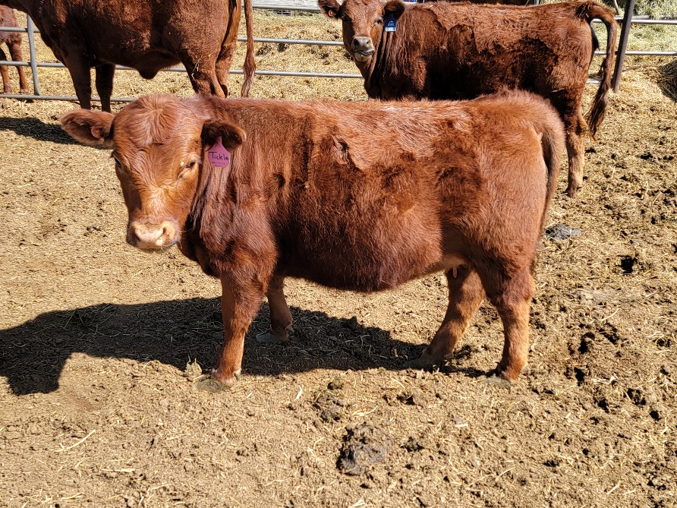
ADCA #050474
Born March 23, 2021
Homozygous polled
Testing done at UC Davis
A2A2 by obligation
Carrier of chondrodysplasia
Sire: Moosters Red Rover #040560
Dam: White Rock Cherry Blossom #039801
$2000
Young heifer, open, ready to breed to a non-carrier bull later this summer for a 2023 calf. Her dam has a lovely milking udder (shown below) and balanced conformation. Sire, Rover, lends great conformation and great feet and legs.
