Celtic Clover with steer at side
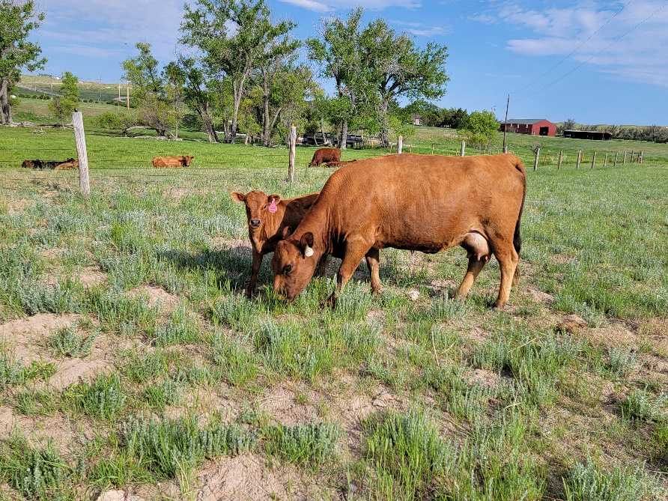
ADCA #038569
Born November 20, 2015
Homozygous polled E+/e red
Testing done at UC Davis
A2A2 by obligation
Sire: PRF Hondo Lane #031963
Dam: Moosters Frostbite #033731
$2400 for the pair
Clover is a beautiful cow that has produced several nice heifer calves and several steers. She is not halter trained, but is easy to be around. Nice depth of body, easy calver. Grass fed only. Dam, Moosters Frostbite, shown below.
