JF Brie with steer calf at side
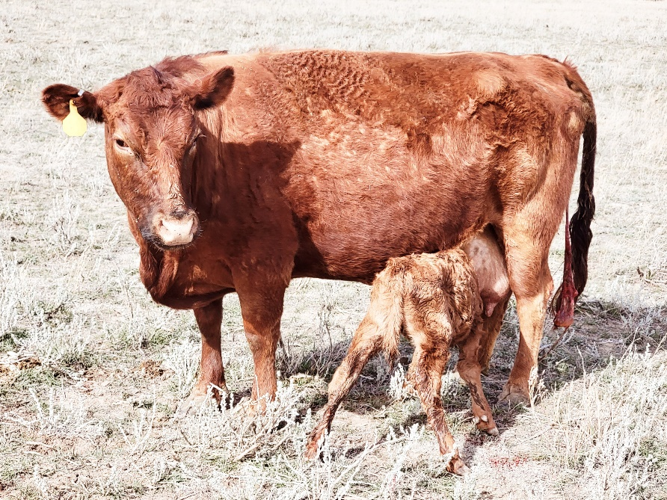
ADCA #039044
Born April 25, 2015
Red, carries one copy of dun
Polled
PHA and chondro free; testing done at UC Davis
A1A1
Sire: Timberview Rio 031806
Dam: Timberview Ashley
$2150 for the pair
Brie is a deep bodied cow with a full and deep udder. She will be sold with her 2022 steer at side. She makes deep and wide calves. Shown below is her 2021 heifer. Brie is not halter trained, but she is sweet and her calves are sweeter!

